**The RISE Trust**

**Guidance for completion of the application for employment form**

Please read these notes carefully before completing your application form. This is important as it provides the only information, we use to assess your suitability for the job and our decision whether or not to progress your application will be based on this information. If you want to complete it by hand, please use black ink.

### Qualifications and training

* As some jobs require no formal qualifications, do not be put off if you have nothing to write in this section.
* As well as telling us about the exams that you have passed, you should also include information about any relevant courses that you have completed.
* Include all qualifications and training which may be part-time as well as full-time.

### Employment experience

* The form asks you to give details, to the nearest month and year, of previous jobs held, and account for any gaps in your employment record.
* Alternatively, some people will have developed relevant skills through part-time or voluntary work. If you include any voluntary work, list the name and address of the group(s) involved.

### Relevant experience

* This section gives you the opportunity to demonstrate why you are suitable for the post. Before completing it, refer to the job description and person specification for the job.
* The job description outlines the main duties of the post, the skills, experience, qualifications and competencies necessary to carry out these tasks.
* Here it is essential to relate your experience to the information given in both these documents by giving specific examples. For example, telling us what you did in your job rather than what the team did and how you demonstrated a particular skill, rather than simply saying that you have it. Please ensure you address all of the points identified on the person specification which will allow you to demonstrate your suitability for the position you have applied for.
* You may wish to draw on skills developed outside of work, whether home-based or social/community activities. These might include running a club or voluntary group, bringing up children etc, as well as previous/present employment, study and training.

### References

* As a community charity, safeguarding and protecting children and vulnerable adults is an integral part of our work. We are rigorous in our reference checks for this reason.
* Verbal **and** written references will be obtained for all posts **before** interview if shortlisted, in accordance with safer recruitment guidelines.
* Please ensure you give references that cover at least the last five years of employment including one from your current line manager.
* If you are unemployed, include your last employer, and if you have worked in a voluntary or unpaid capacity e.g., as a member of a Parent Teachers Association, you could include the chair of the committee among your references.

### Criminal Record

With some exceptions having a criminal record will not necessarily bar an individual from working with us. This will depend on the nature of the position sought and the circumstances and background of the offence. If you have declared a criminal record, which we believe is relevant to the post we will discuss this with you at interview.

Applicants are asked to declare any criminal record on the page marked Criminal Records, Disqualification & Declaration as follows:

* If the post you are applying for is not exempt from the Rehabilitation of Offenders legislation, e.g. jobs that do not involve working with children, you must declare only ‘unspent’ convictions.
* If the post is exempt from the Rehabilitation of Offenders legislation, you must declare all convictions, cautions, reprimands, or final warnings on your criminal record, both spent and unspent. Successful candidates will also be asked to consent to an Enhanced Disclosure via the Criminal Records Bureau or Disclosure Scotland or, in Northern Ireland, a POC check before employment commences.
* The amendments to the Exceptions Order 1975 (2013) provide that certain spent convictions and cautions are ‘protected’ and are not subject to disclosure to employers, and cannot be taken into account. Guidance and criteria on the filtering of these cautions can be found on the disclosure and Barring Service.

The covering letter will explain which section applies to you. The details of any criminal record should be noted on the page marked Criminal Record/Disqualification/Other, which should be removed from the application form and returned in a sealed envelope marked with your name and ‘criminal record/other’. Any information declared will be kept confidential and in line with data protection principles.

**Disqualification from working with children or vulnerable adults**

If you are disqualified from working with children or vulnerable adults we are unable to consider you for jobs that involve working with these groups. You are therefore asked to declare whether you are disqualified on the page marked Criminal Records, Disqualification & Declaration.

Disqualification can occur through a number of routes:

* being on a disqualification list, eg List 99, POCA List, National Assembly of Wales List, DWCL Scotland, DWC (NI) List, Department of Education (NI)
* being subject to a Disqualification Order
* under Disqualification from Caring for Children and Day Care Childminding Disqualification legislation (separate form enclosed)

**Commitment to people with protected characteristics:** Disabled applicants and those with protected characteristics can face additional challenges to gaining employment and we are committed to promoting employment opportunities for all people.

**Support and assistance**: We also aim to ensure that our recruitment process is flexible and supportive to individual needs so please contact us if you need any assistance in completing the application form or if you need information in an alternative format.

### Returning the form

* Please keep a copy of the form. The interview will include questions about information given.
* Please return your completed application form to The Rise Trust address at the front of this pack, by the closing date, via post or email. If it arrives late, we may not be able to consider you.
* Remember we are only able to measure your suitability from the information you provide.
* If you require any further advice on any of the above, please phone or email the recruiter named in the attached letter.
* All applications received are dealt with in accordance with the requirements of the Data Protection Act 1998 and 2003 and theGeneral Data Protection Regulation 2018.



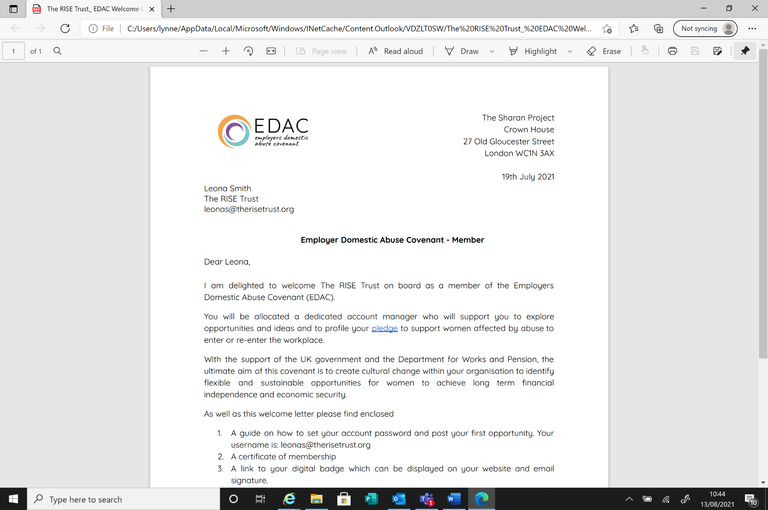“Through unconditional love, commitment & passion we seek to enable all children, young people and adults to be the best they can be.”

The RISE Trust – The Oaks – Chippenham – Wiltshire – SN15 1DU – Tel: 01249 463040

Limited by Guarantee – Reg no: 5662408 Charity no: 1114446