The RISE Trust Trustees
“Through unconditional love, commitment and passion we seek to enable all children, young people and adults to be the best they can be.”

- ARE YOU LOOKING FOR AN OPPORTUNITY TO GIVE BACK TO YOUR COMMUNITY?
- ARE YOU PASSIONATE ABOUT MAKING A DIFFERENCE TO THE LIVES OF YOUNG PEOPLE AND THEIR FAMILIES?
- ARE YOU LOOKING FOR AN OPPORTUNITY THAT FITS AROUND YOUR OTHER LIFE COMMITMENTS?
We are a local community charity supporting disadvantaged children and young people (aged 2-19 years) in areas of deprivation within North Wiltshire. Our not-for-profit charity aims to support children/young people in our community to be confident and empowered to make positive life choices, successfully participating in society as happy, independent, and responsible individuals through developing and enhancing their skills, capacities and capabilities.
Many of our children and young people may be living in poverty, facing poor home conditions/overcrowding, experiencing domestic abuse, vulnerable to criminal exploitation, displaying anti-social behaviour, experiencing mental health difficulties, managing substance misuse issues, poor school attendees, LBGTQ+ and/or excluded or at risk of exclusion.
Supporting young people is at the heart of our commitment to the community. We offer free safe spaces, youth clubs, pop-ups in local schools and detached outreach to young people aged 8 – 19 years in Calne, Chippenham, Corsham, Malmesbury, Purton, and Cricklade. Our youth workers go to the places young people frequent especially those who are reluctant to come to indoor sessions. We believe that our young people need to feel safe, listened to and have their voices heard. Our work is free-of-charge and aims to provide early help so we can try to help young people with difficult life choices, relationships, substance usage and behaviour.

In addition, we have our pre-school @ The Oaks, which provides high quality pre-school childcare and currently has an Ofsted rating of Good. Our other services include a Contact Centre in Chippenham, a mentoring service to the Chippenham primary schools and a Parent Support Advisor that goes into local primary schools.
About the role
This is an important time to join the Trustees as we work to deliver our strategic ambitions. Being a Trustee is an excellent way to develop your skills and can be a fascinating and rewarding experience.
“Being a RISE Trust trustee reminds you of your whole community, not just your immediate circle, and the positive impact we can each have on each other. It has helped give me confidence and experience whilst volunteering in a time frame that meets my needs and the needs of my family. By volunteering I feel like I am paying back to the community I live in.”
Our new Trustees will be joining an experienced Trust Board, working alongside an inspiring CEO and senior leadership team, our dedicated colleagues and volunteers.
You will attend four Trustee meetings a year for two hours. However, if the needs of the trust merit additional meetings these may take place face-to-face or via Microsoft Teams. There will be an additional time commitment to review meeting papers which are circulated in advance of trustee meetings.
This is a voluntary role, and we are able to reimburse expenses.
We are seeking new Trustees for specific roles:
- Supporting our young people’s service, preferably with ‘lived experience’
- Finance expertise
- Fundraising experience
- Strategic planning expertise
- …we also welcome applications for other areas of skill and expertise
Equality, Diversity and Inclusion
The trust and the trustees are committed to learning around equality, diversity and inclusion and are dedicated to a continuous process of challenging ourselves to increase inclusivity across every area of our work with the children and young people and within our internal systems. We welcome and encourage applications from all sections of society and from those with the potential to make great trustees. We particularly welcome applications from people from ethnic minorities, LGBTQ+ and disability groups, as well as those who have lived experience of multiple disadvantages, as these groups are currently under-represented on our board. We also welcome applications from first-time Trustees.
How to apply
Please submit an expression of interest in your preferred format – CV, written statement, etc to claireh@therisetrust.org
For an informal introduction with the Chair or CEO, or if you have any other questions about the role, please contact claireh@therisetrust.org or call us on 01249-463040
Closing date: xxx
Interviews: xxx
The RISE Trust is a Christian community charity where Christian values underpin the RISE Trust’s approach to social action within the community. We would therefore politely request the person is respectful of our prayer with and for staff, volunteers and service users, as and when appropriate.
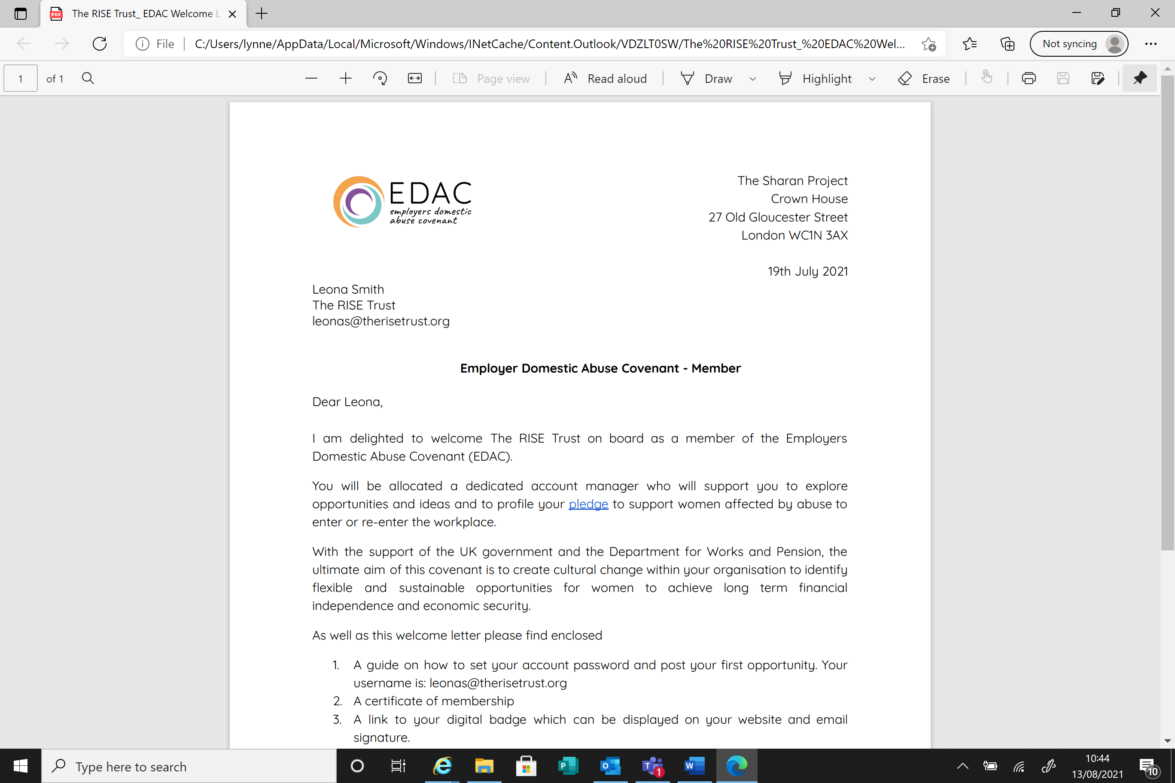
This organisation is committed to safeguarding and promoting the welfare of children and young people and expects all staff and volunteers to share this commitment.
In accordance with safer recruitment protocols, we will request references in advance of interviews, for shortlisted candidates.

