
THE RISE TRUST STAFF & VOLUNTEER CHARTER
We do the right thing for the right reasons. “Through unconditional love, commitment & passion we seek to enable all children, young people and adults to be the best they can be.”

- We share a common vision for how we want The RISE Trust to be and we regularly review this – we affirm our mission statement
- We are a Christian charity loving everyone unconditionally whatever their background, faith or personal circumstances – we are non-judgemental
- We are compassionate to those in difficulty and understanding of their feelings whilst empowering them to face life’s challenges and move on with their lives – we go the extra mile
- We are kind and positive - recognising achievement, celebrating success, affirming and complimenting each another
- We accept personal responsibility for our own actions, ensuring we keep ourselves and others safe at all times
- We have clear values and beliefs for The RISE Trust - seeking constantly to improve our practice and knowing that making mistakes and apologising is an important part of our learning
- We believe in enabling children and adults to feel ‘safe’ within an environment where there are secure boundaries, consequences and rules – we have the child at the centre of everything
- TEAM (Together Everyone Achieves More) - we are open-minded and work together to improve and develop our own and other people's practice
- We aim to develop good relationships with everyone in the RISE community and have high expectations of each other
- We show openness and honesty in communication giving people time to explain
- We listen to each other and take what others say into account
- When others disagree with us, we do not treat this as a personal attack, - we expect the disagreement to be exercised with understanding
- We only share information with those people who need to know – We adhere to confidentiality at all times
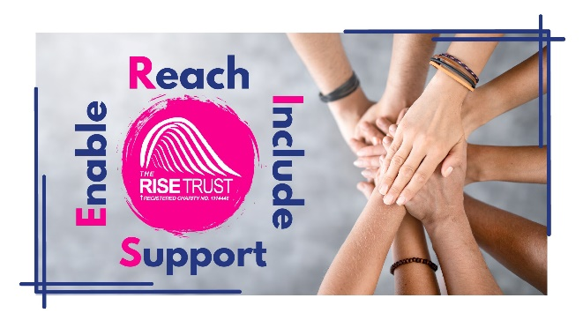
- Our own and others wellbeing is of vital importance and look after each other – we have a good laugh (but ensure that we are mindful of what is going on around us)
- We present a positive working role model to the public adhering to our smart dress code, personal professional conduct and staff behaviour policy
- We have a life outside of the organisation and develop our own personal interests

